Funeral Prayers
for
the Repose of the Soul
of

……………………..



Born: …….~ …………,

Entered the Fullness of Life: …….~ …….,

…………Catholic Church, ………….., ~

Celebrant: ………………. .

ENTRANCE HYMN:

THE INTRODUCTORY RITE:

Priest: In the name of the Father, and of the Son, and of the Holy Spirit.
People: Amen.
Priest: The Lord be with you
People: And with your spirit.

OPENING PRAYER: (Priest)
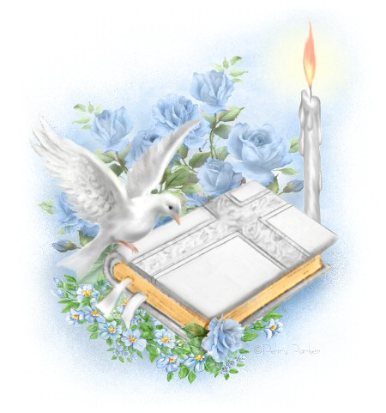
People: Amen.

LITURGY OF THE WORD

FIRST READING: Reader:

A reading ……………..

The Word of the Lord.

People: Thanks be to God.

RESPONSORIAL PSALM:

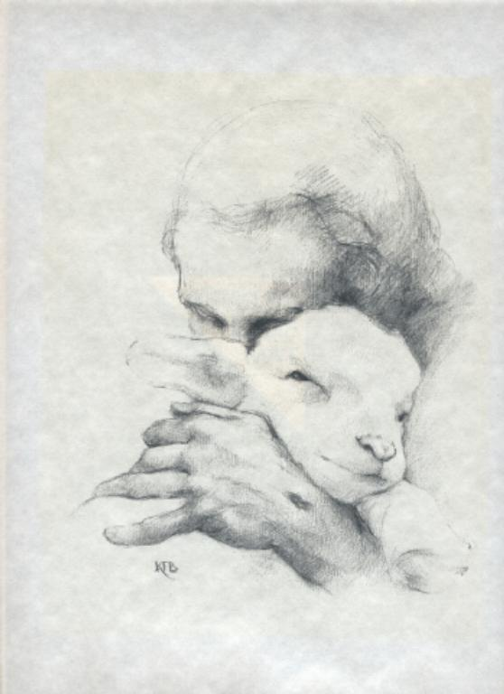

GOSPEL ACCLAMATION:

Priest: The Lord be with you.

People: And with your spirit.

Priest: A reading from the holy Gospel according to ………….

People: Glory to you, O Lord.

GOSPEL: Fr…………………

The Gospel of the Lord.

People: Praise to you, Lord Jesus Christ.

HOMILY: Fr ……………..

PRAYERS OF INTERCESSION: Reader:

People: Amen.

Personal Tribute:
FINAL COMMENDATION & FAREWELL

SONG OF FAREWELL:

Priest: Saints of God, come to …. aid! Hasten to meet ….,
Angels of the Lord!

All: Receive ….soul and present ….. to God
the most high.

Priest: May Christ, who called you, take you to himself;
May angels lead you to the bosom of Abraham.

All: Receive ….. soul and present …… to God
the most high.

Priest: Eternal rest grant unto …., O Lord, and let perpetual
light shine upon …...

All: Receive …. soul and present …… to God
the most high.

THE LORD’S PRAYER:

Our Father,
who art in heaven,
hallowed be thy name;
thy kingdom come,
thy will be done
on earth as it is in heaven.
Give us this day our daily bread,
and forgive us our trespasses,
as we forgive those
who trespass against us;
and lead us not into temptation,
but deliver us from evil.

Amen.


BLESSING:

RECESSIONAL HYMN:



………family wish to sincerely thank everyone
who attended this Funeral Prayer Service today
and all who have offered their loving support in so
many different ways.

Following these Funeral Prayers, burial will
be at ………………….

At the conclusion of the burial, please join us
for light refreshments at ………………….



‘Rest In Peace ……….

